Create a AWS S3 Bucket and Configuring as a Static Website Hosting
Part -A
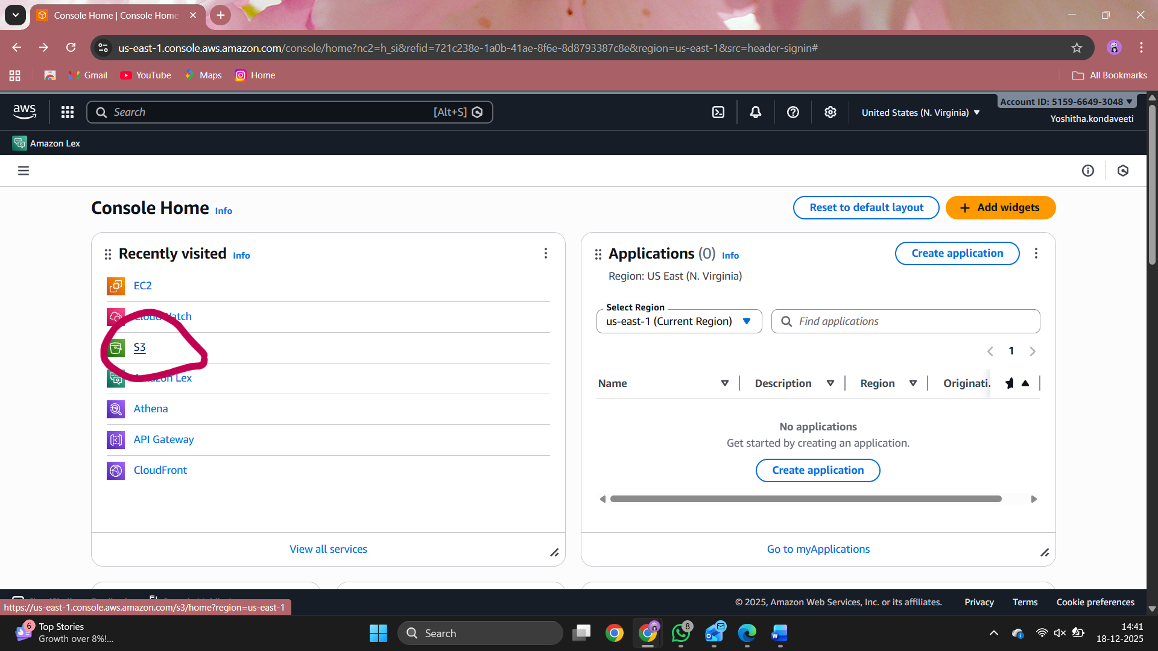
Go to this s3 in aws .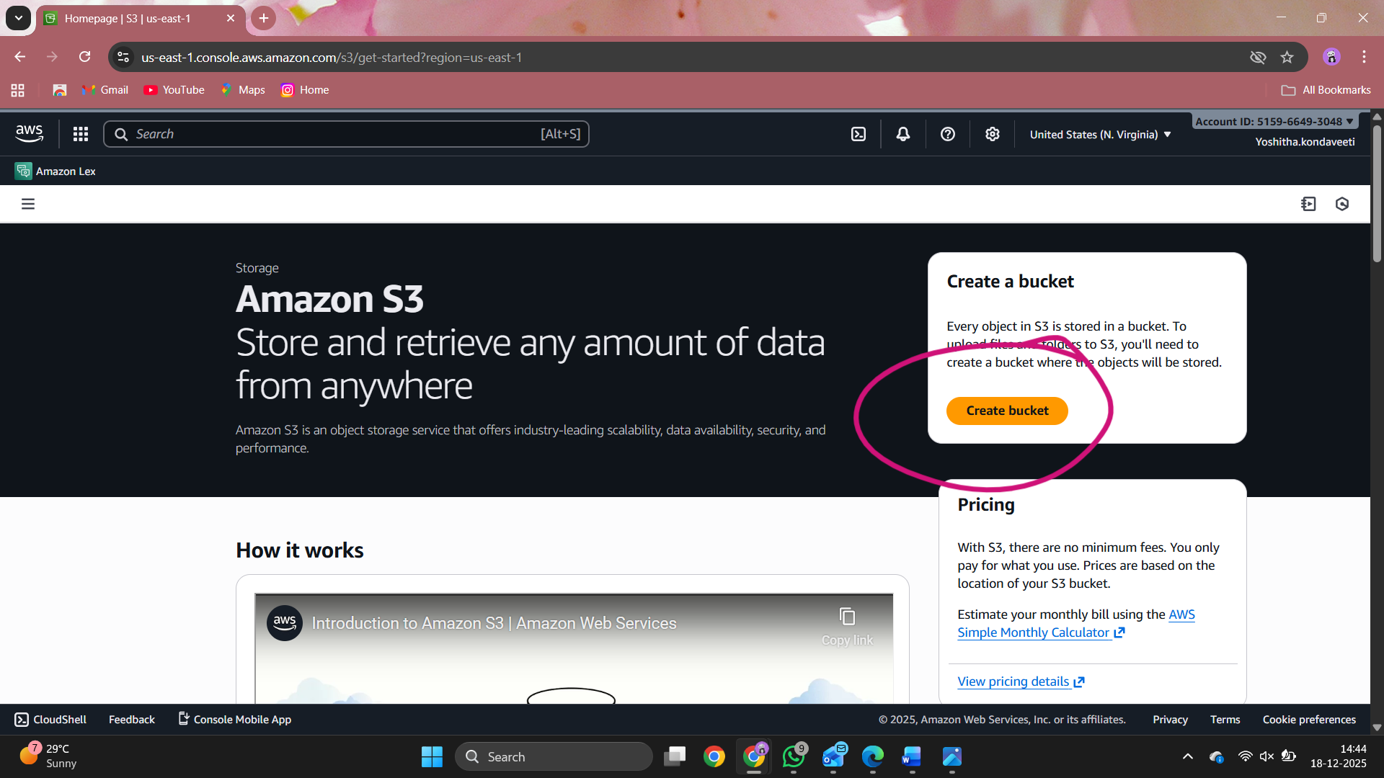
Click create bucket .
Bucket details :
- Choose Bucket Name - Bucket Name Should be Unique
- AWS Region - Choose a region close to you or the region where you want to create the bucket (Example — Mumbai)
- Object Ownership - Enable for making Public, Otherwise disable
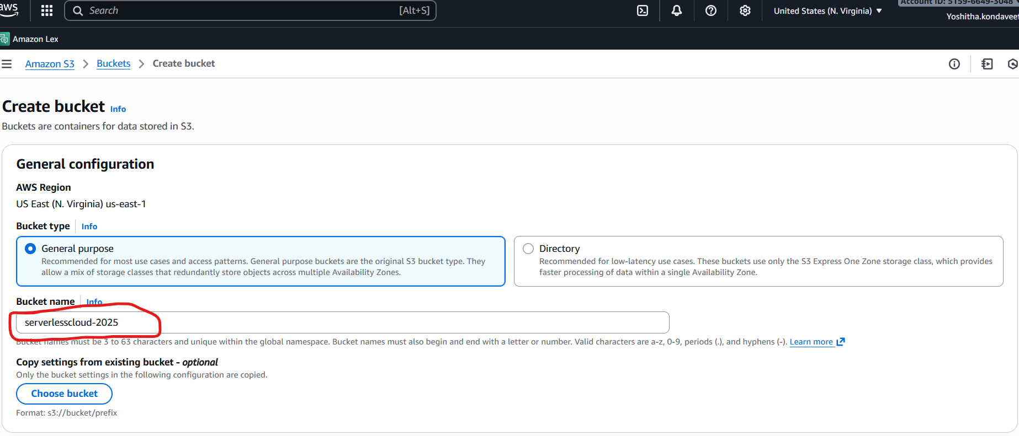

Now enable ACLs and select bucket
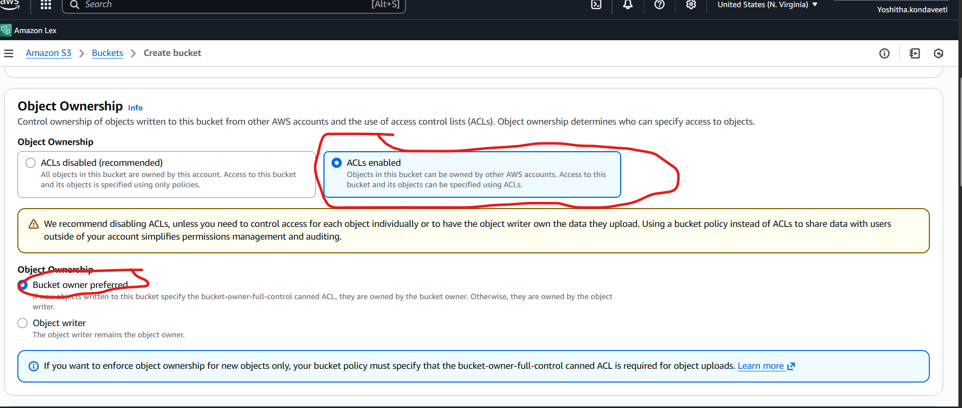
- Uncheck (Block all public access) for the public, otherwise set default. If you uncheck (Block all public keys).
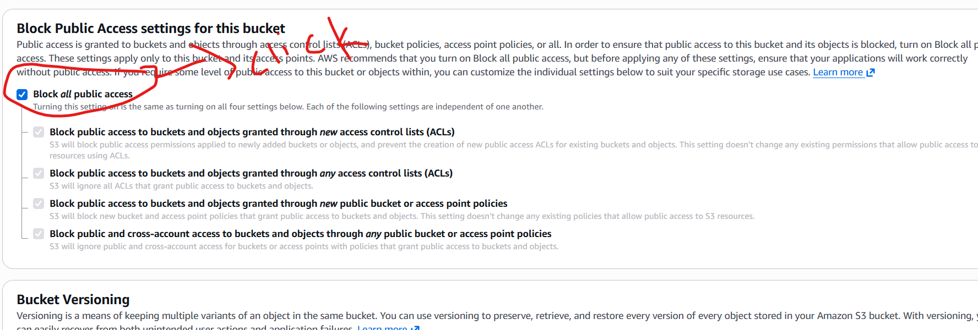
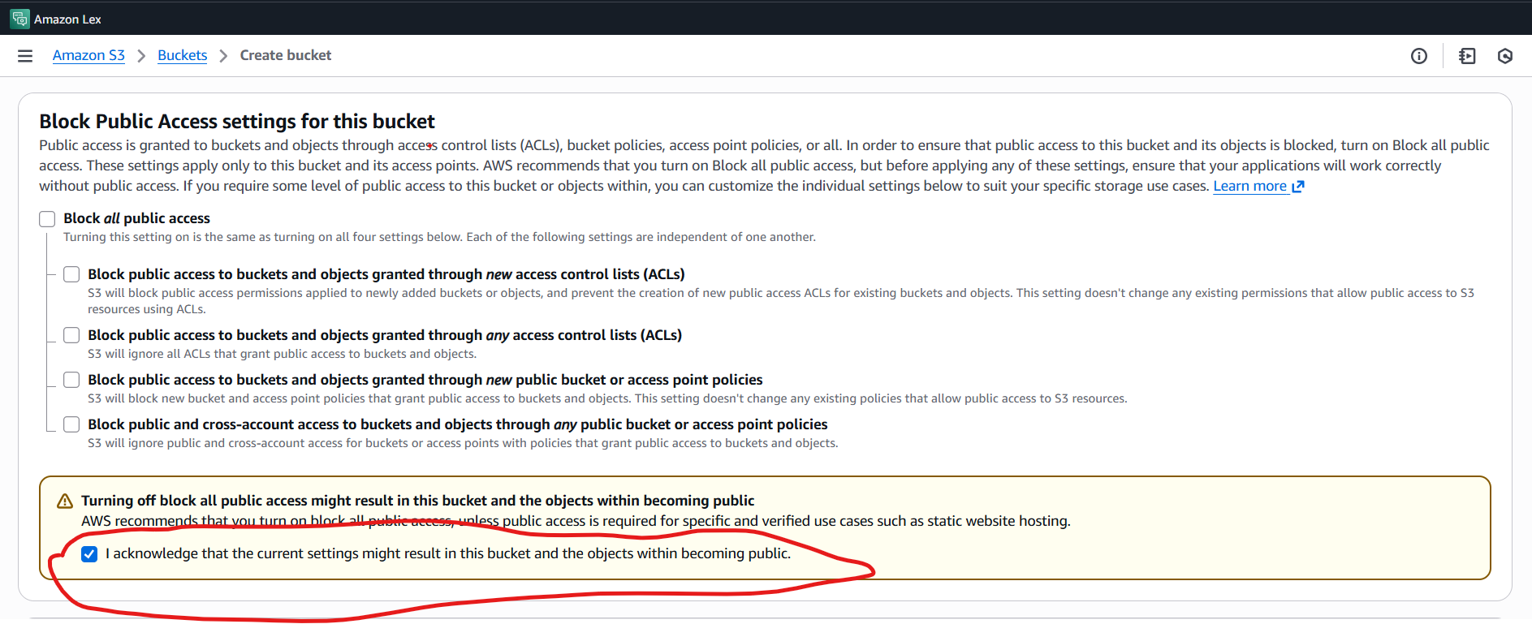
Disable Bucket Versioning
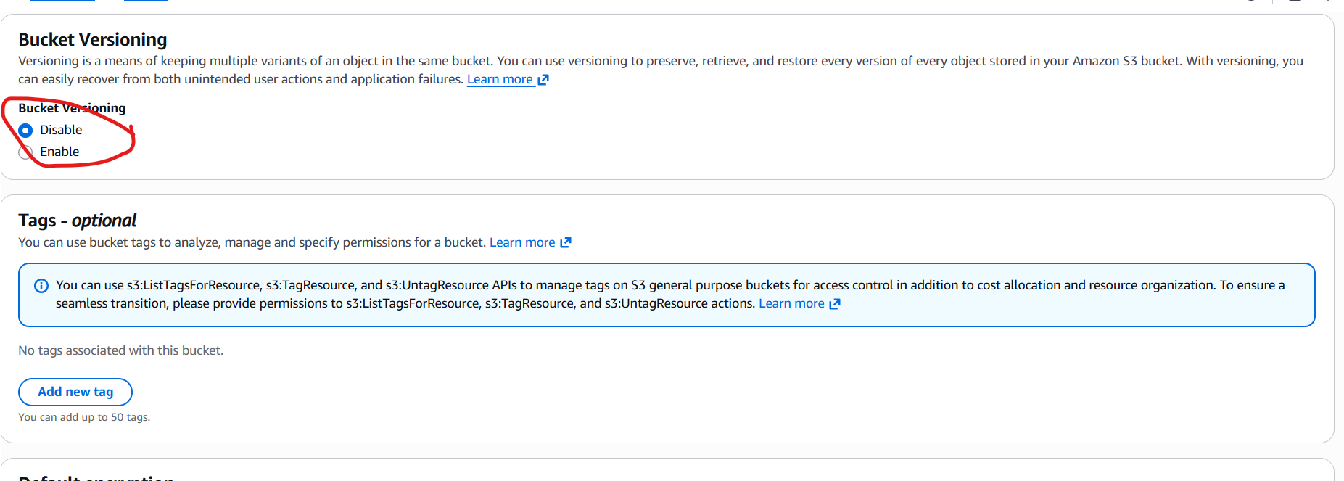
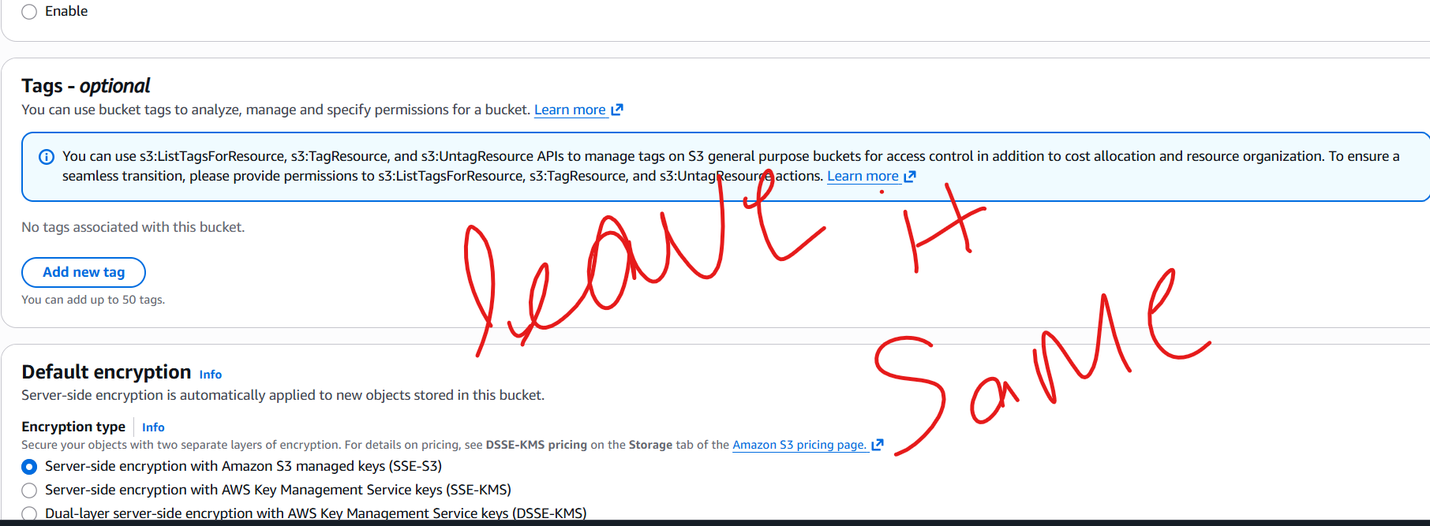

- Bucket Versioning:- You have to do Nothing (Disable)
- Tags(0) : Optional
- Default encryption: Disable

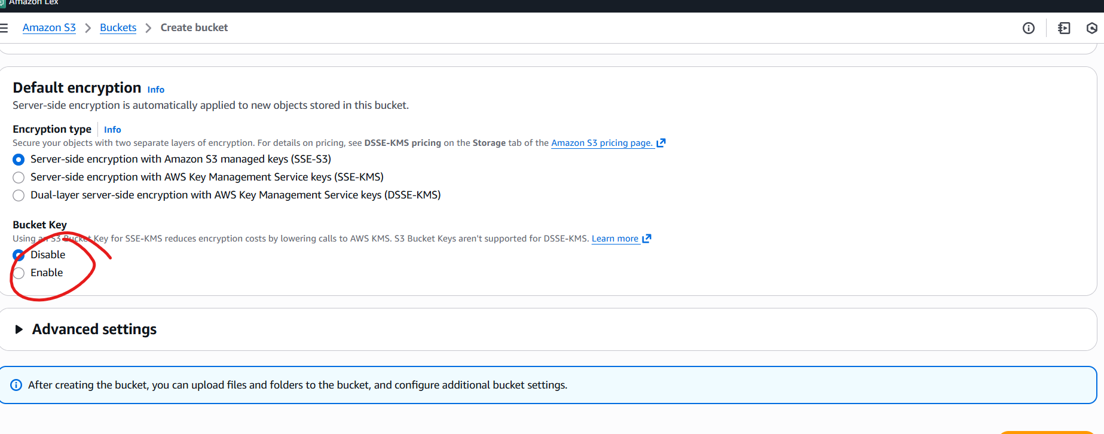
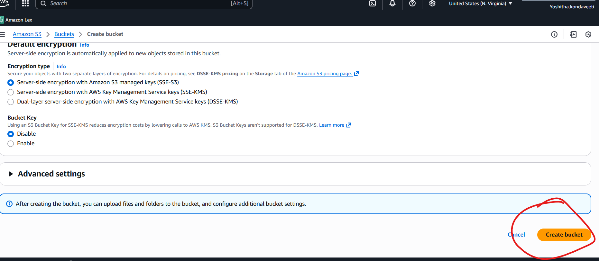
Click create bucket
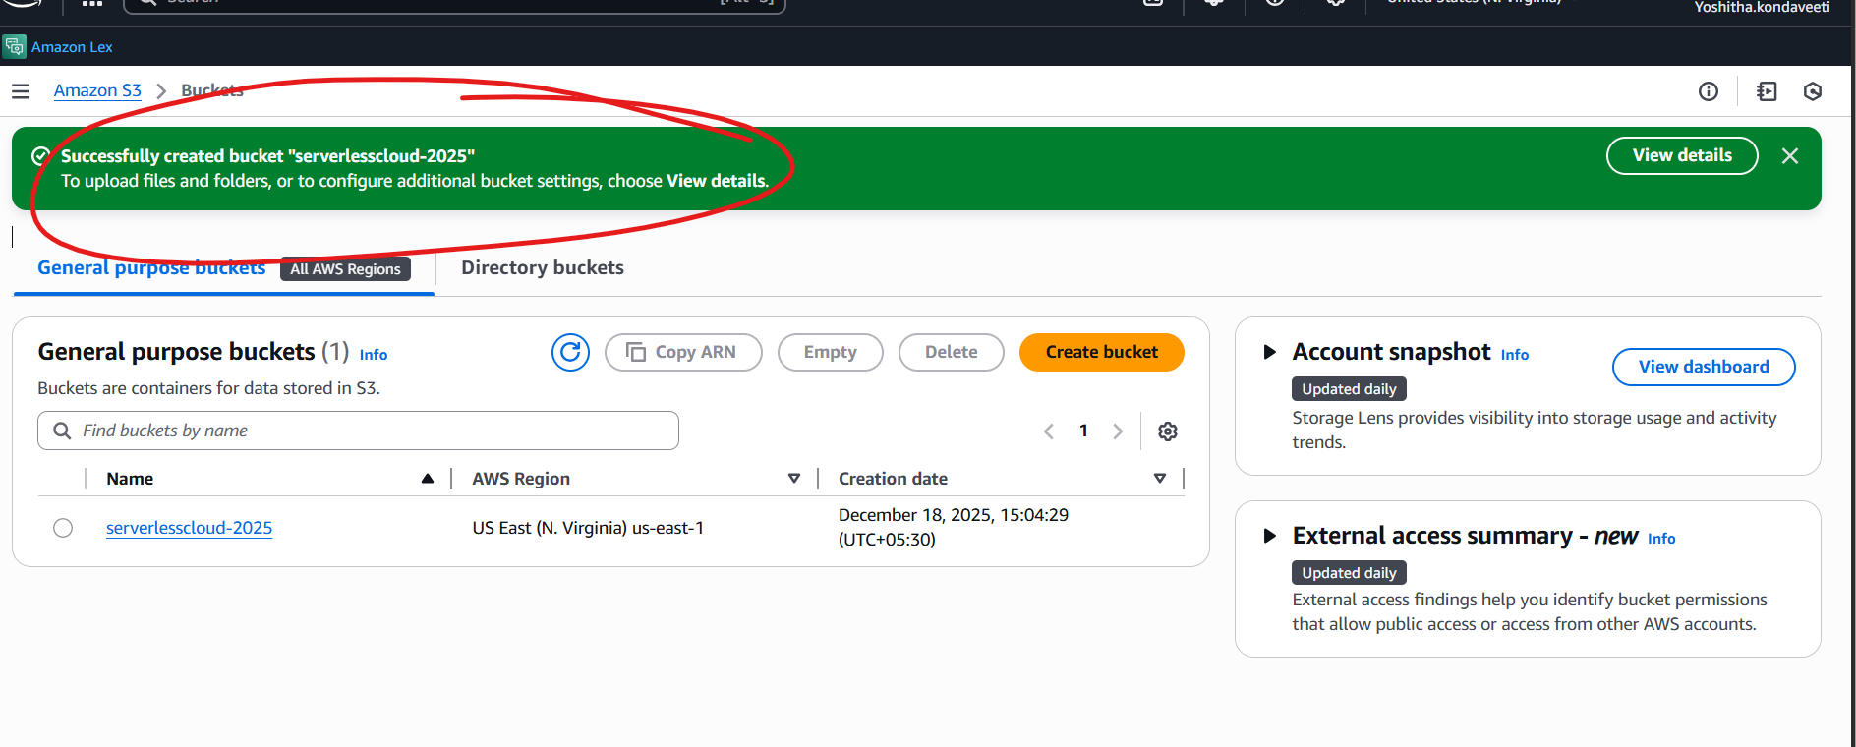
Congratulations you have successfully created a bucket
PART-B- Configuring as a Static Website Hosting
Note for part B – save some html folders in your pc .
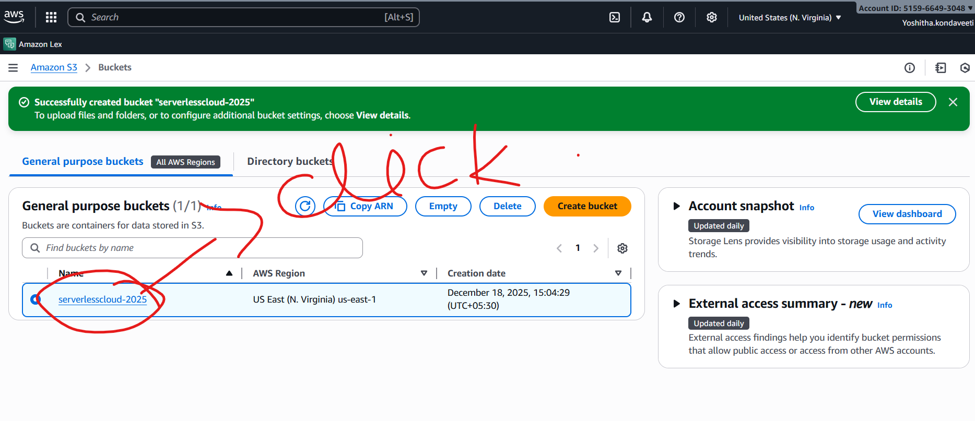

Click that link
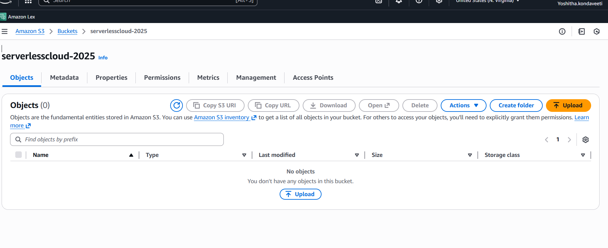
Now you can see this
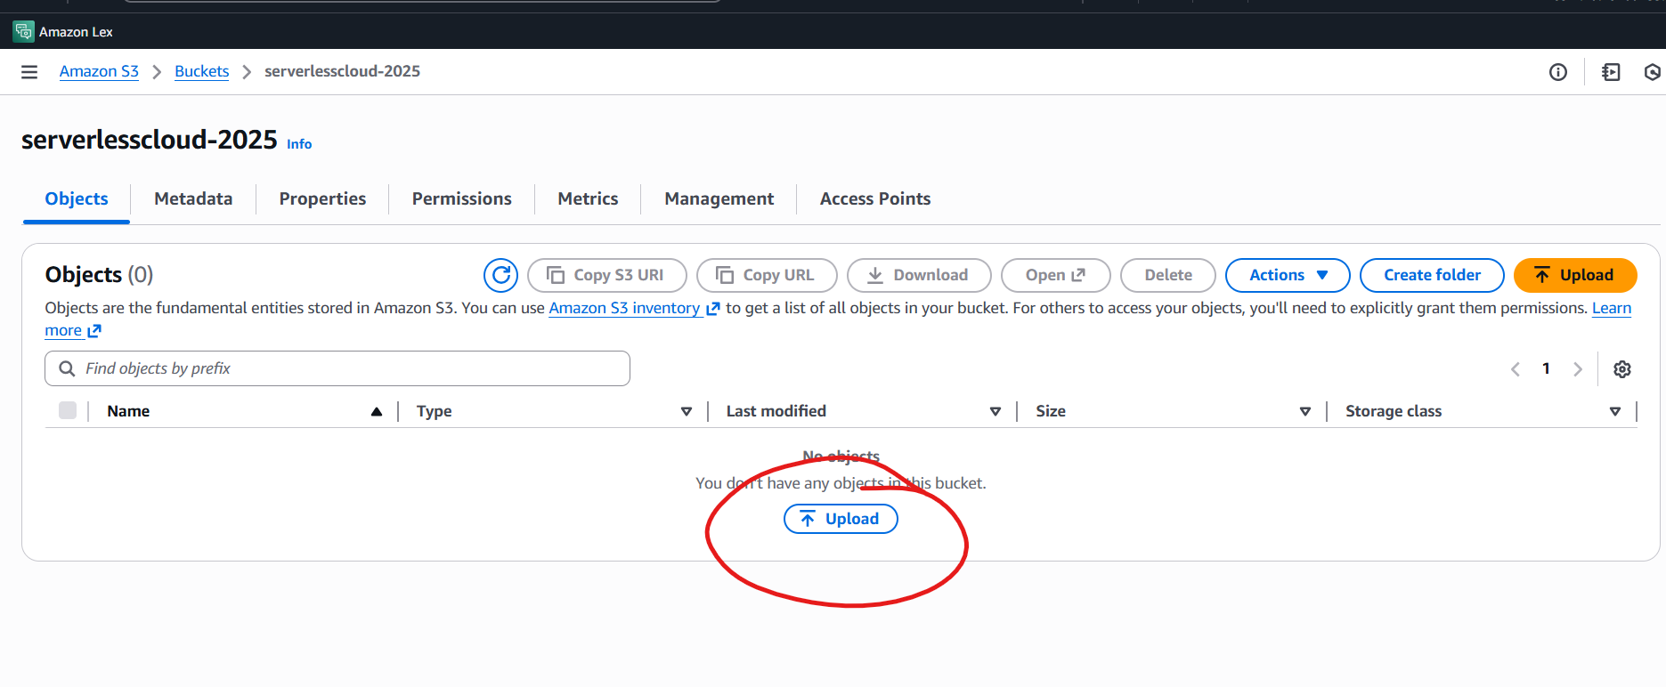
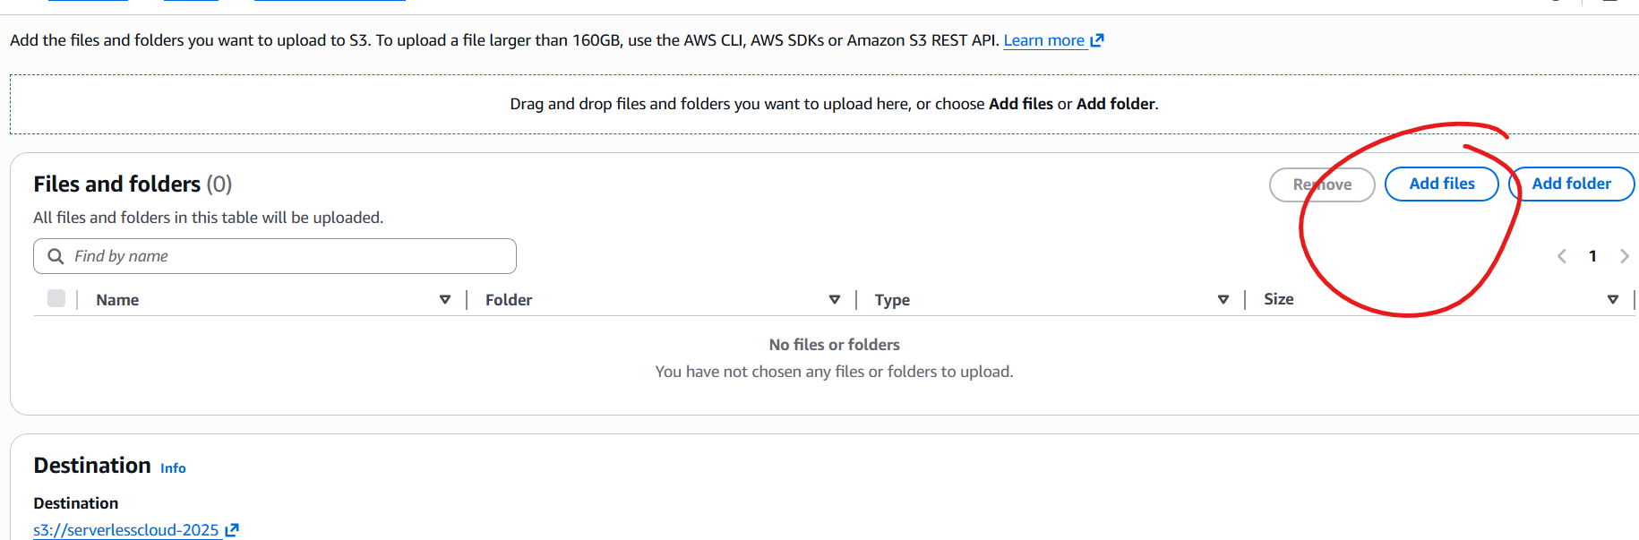

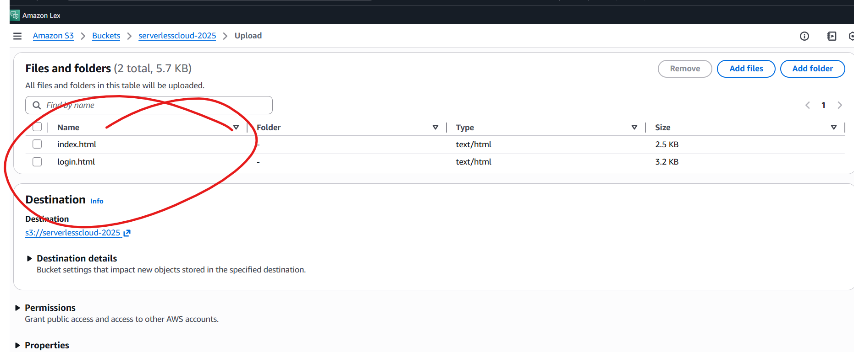
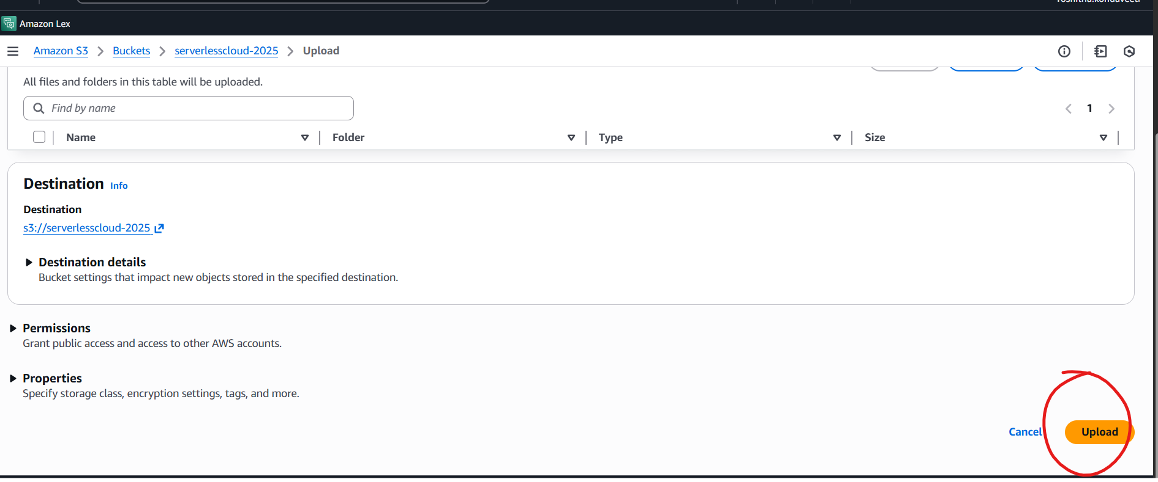
Now click upload
You can see

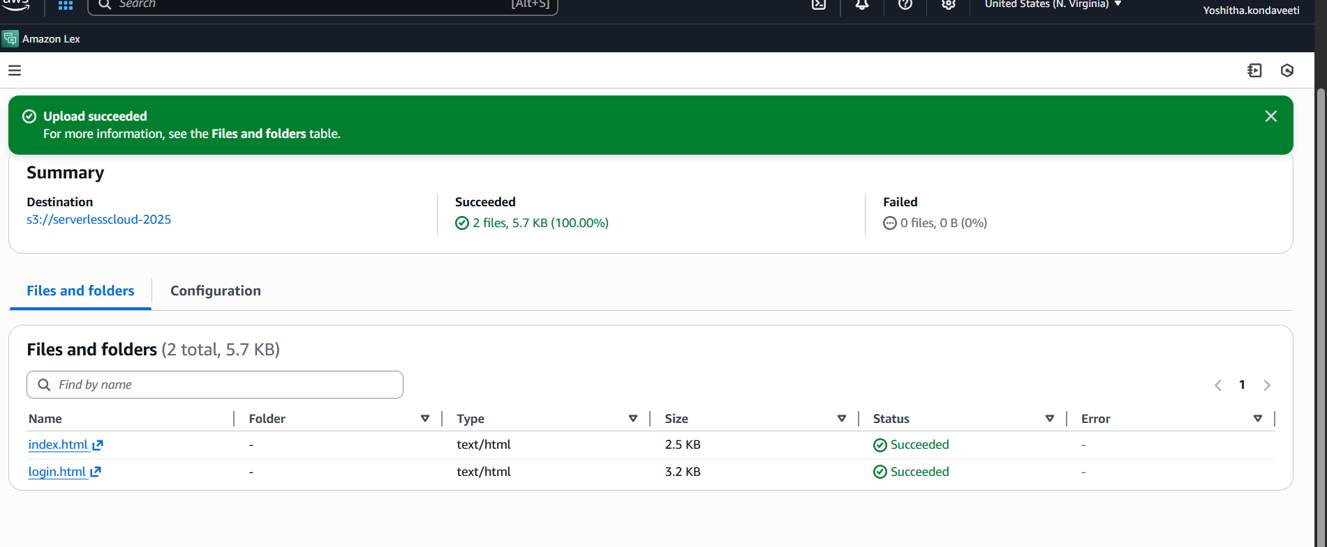
Go back to Buckets and

Now go to permissions
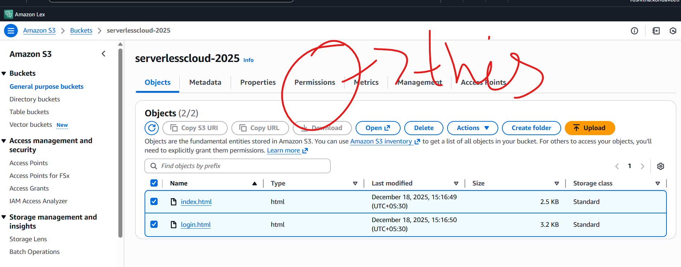

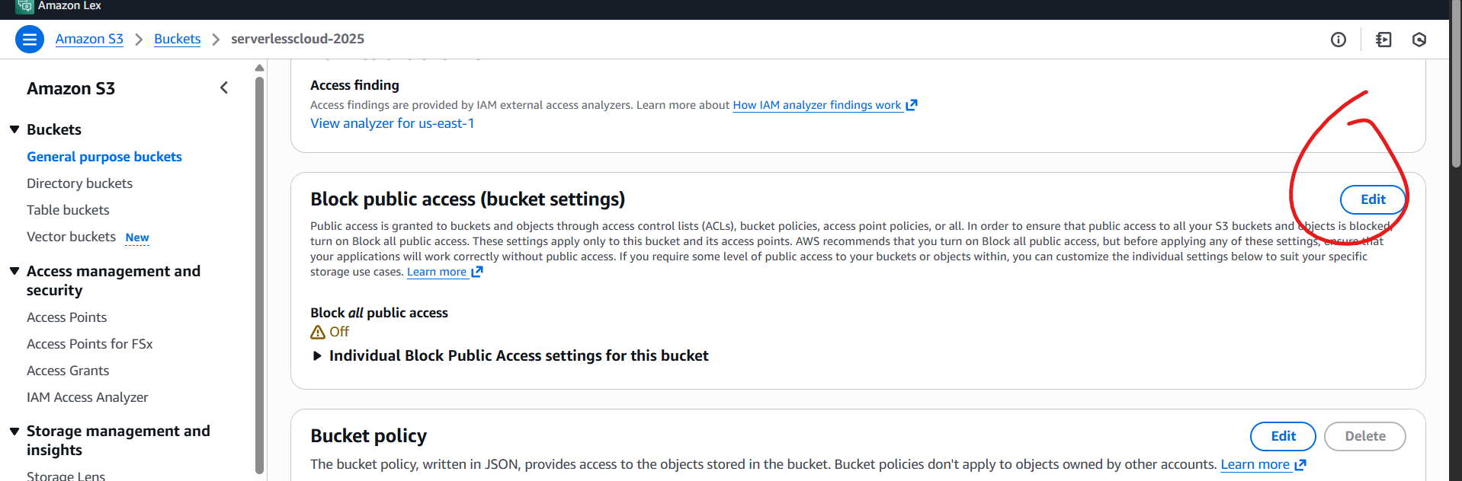
Make sure it look like this
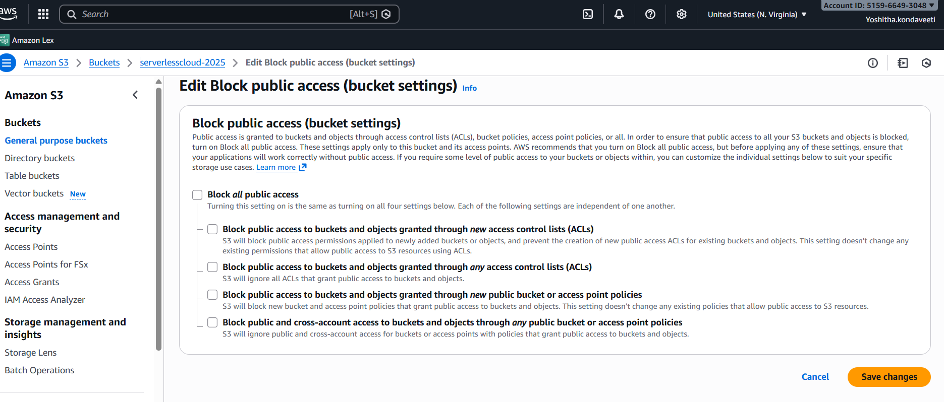
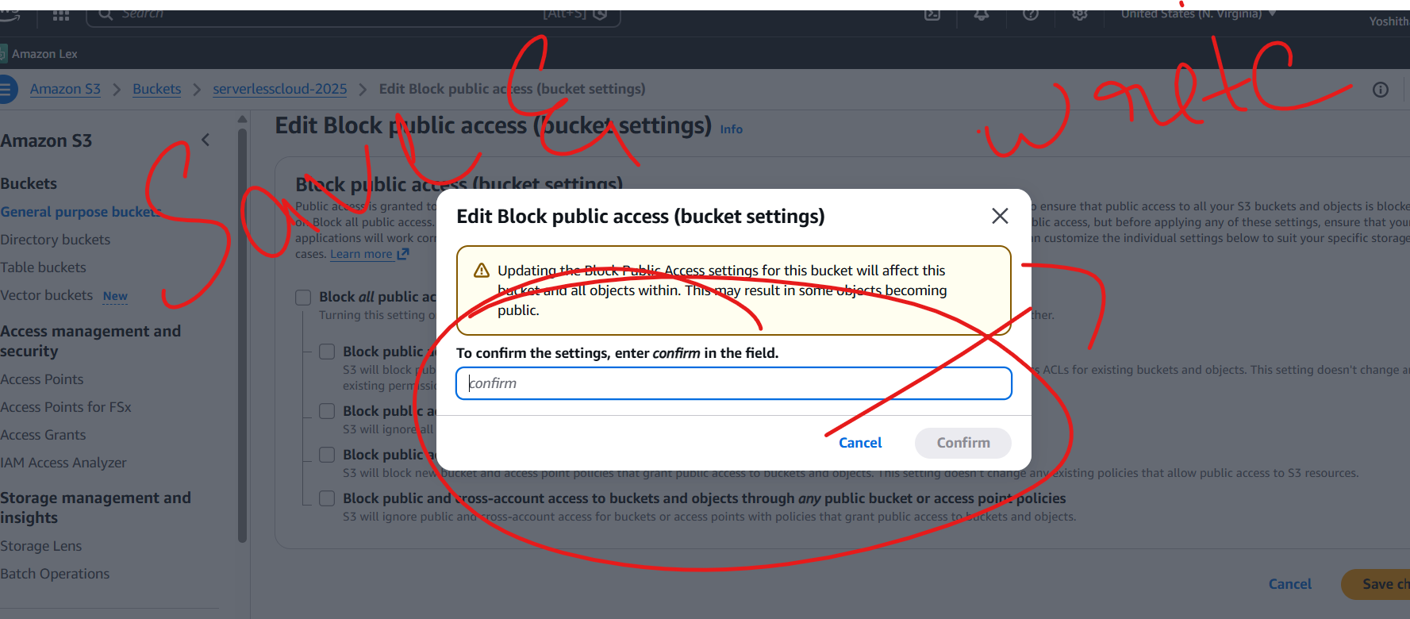
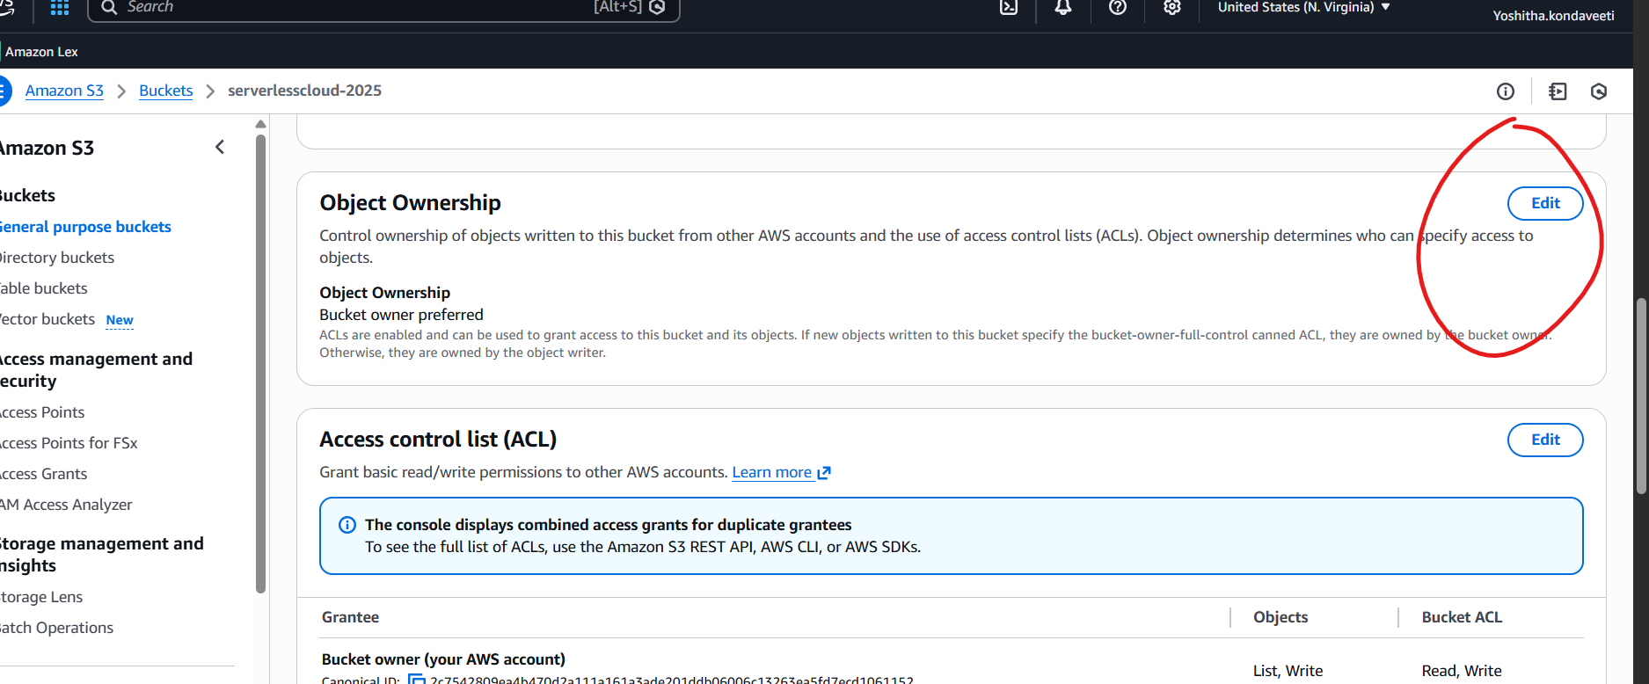
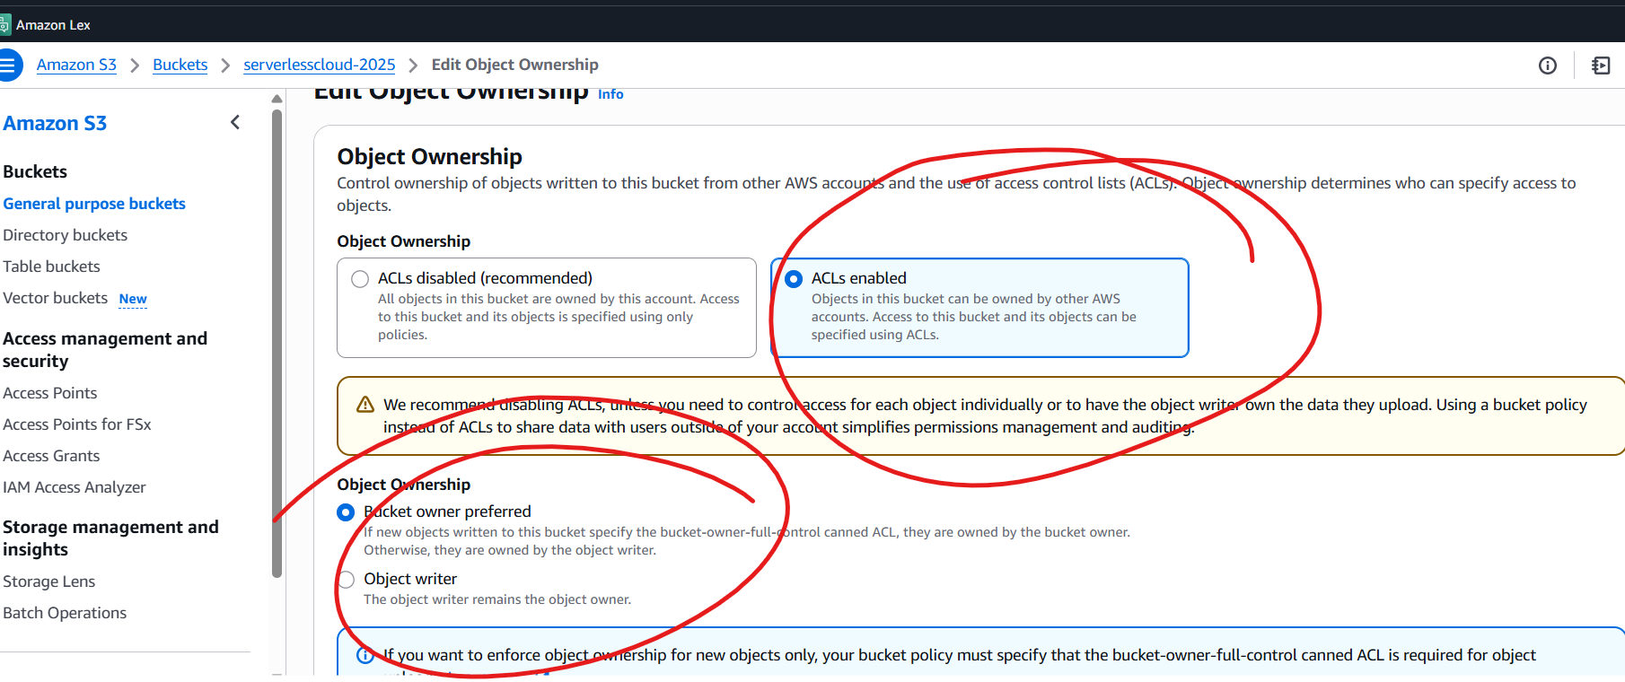
Save
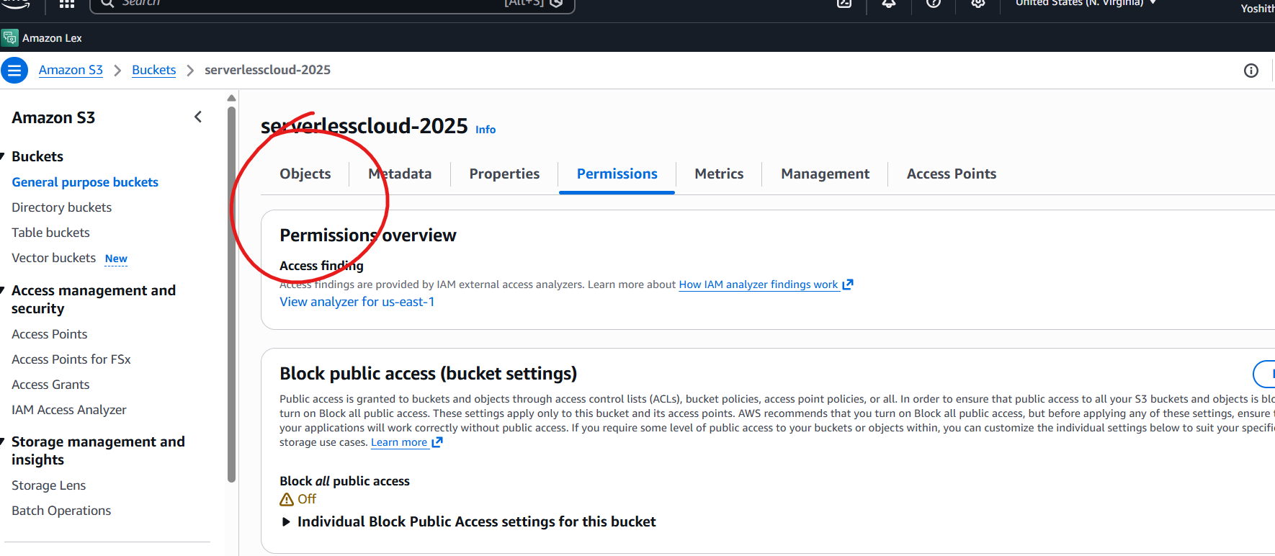
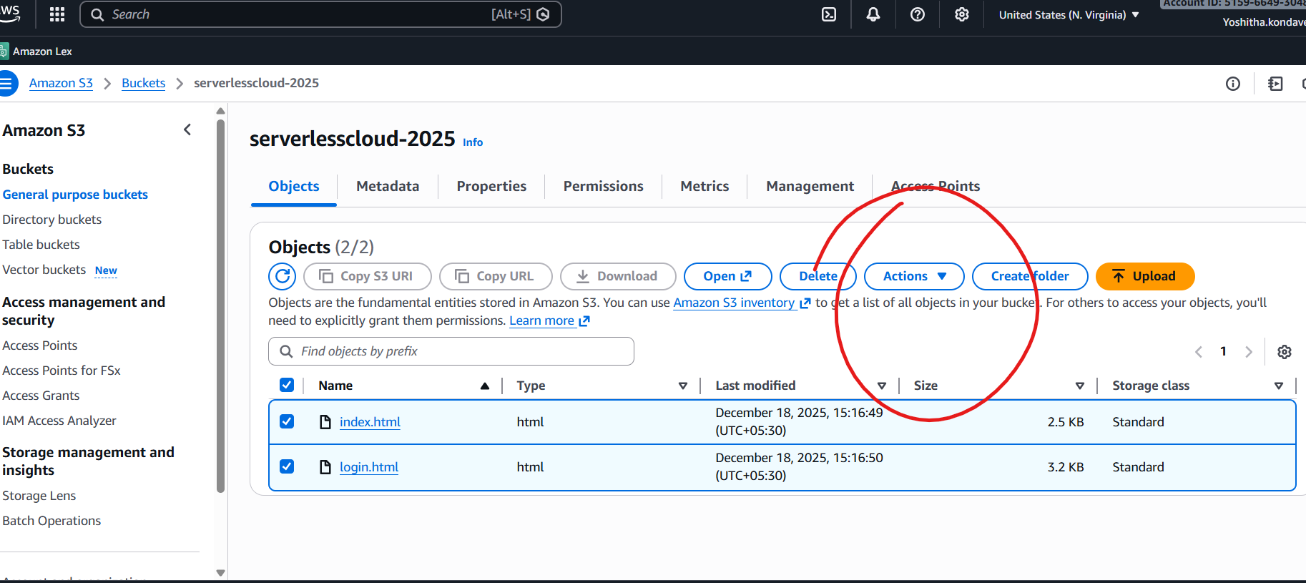
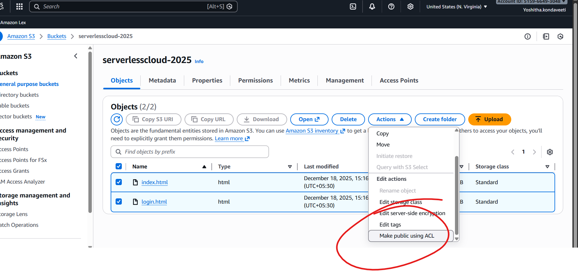
Now click objects for the following link
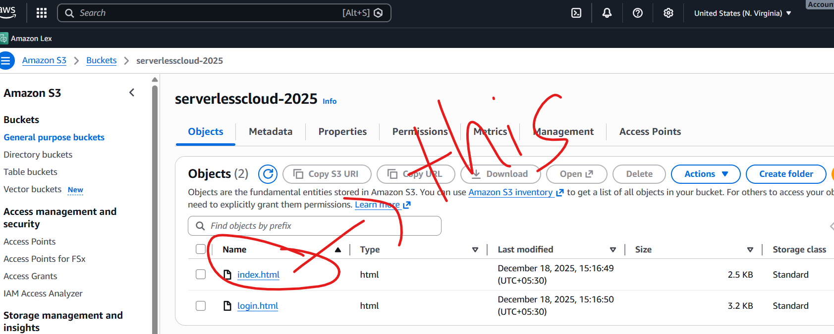

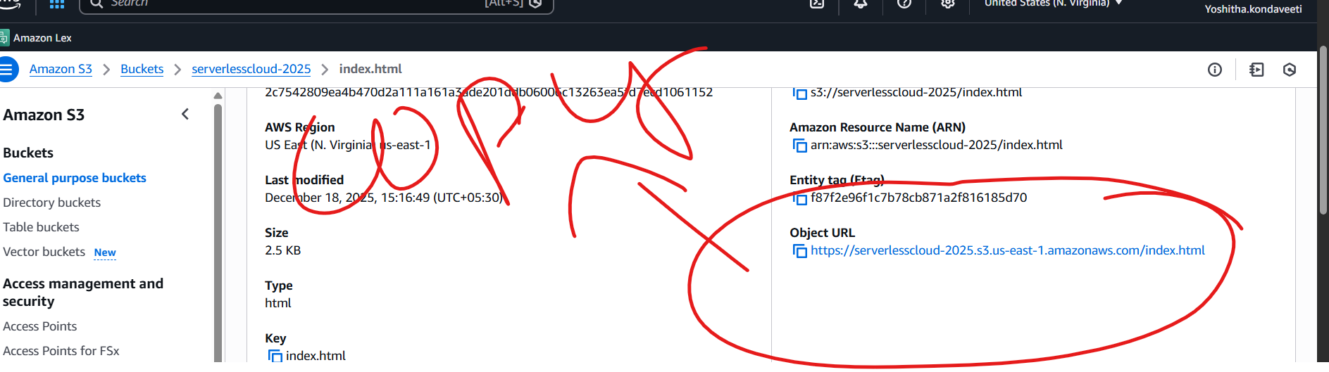
Copy object url
If project is running in html it will be hosted
Check out your Website!
- Directly Paste this URL into the Other Tab or your other System.
- Congratulation, Now Your Website is available in the Public.
OUTPUT:
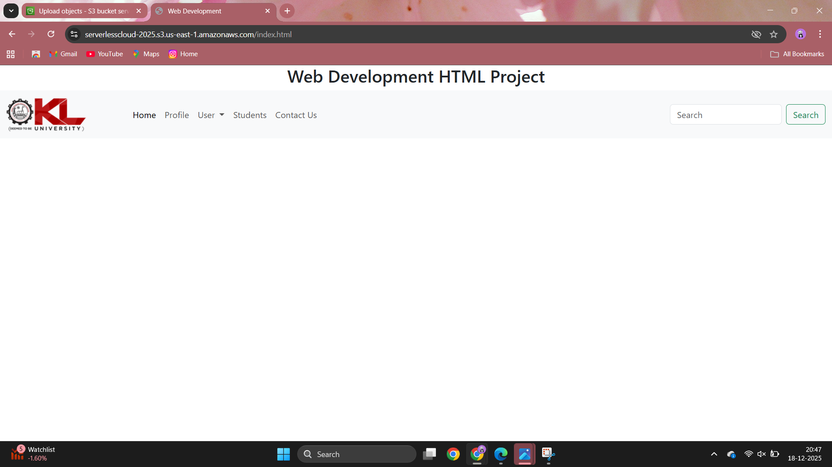
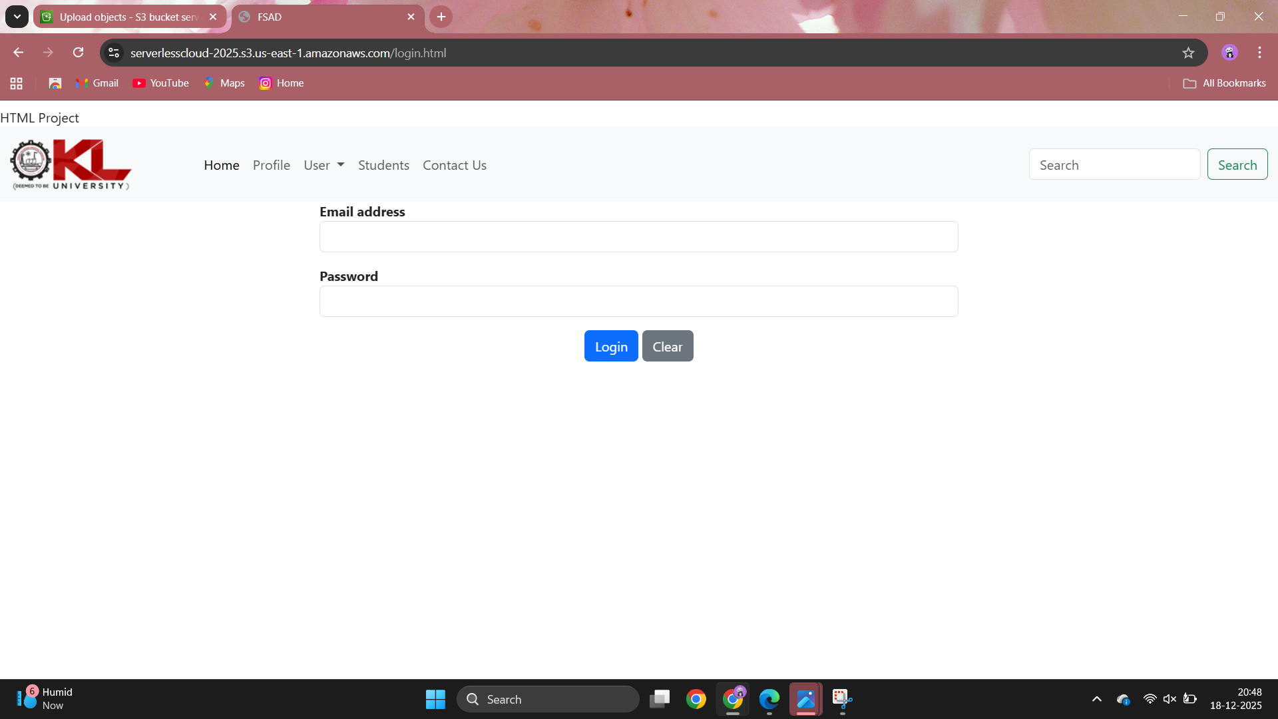
THANK YOU

2300080137

